**Project Design Phase**

**Solution Architecture**

| Date | 15 February 2025 |
| --- | --- |
| Team ID | SWTID1743519094 |
| Project Name | BookStore |
| Maximum Marks | 4 Marks |

**Solution Architecture Diagram:**

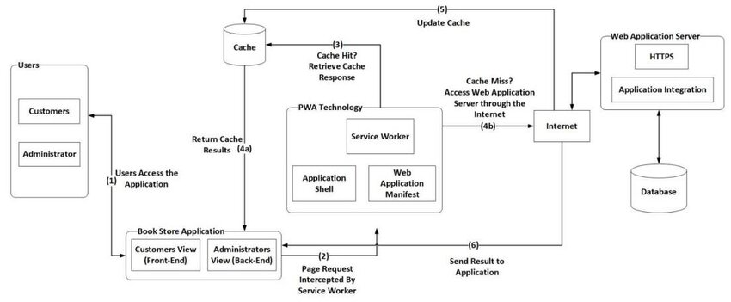

*Figure 1: Architecture and data flow of the Bookstore MERN Application*